NAMA : RAHMANIA ANGGRAINI

KELAS : SI4708

NIM : 102022300034

JURNAL MODUL 3 WAD

1. routes/web.php

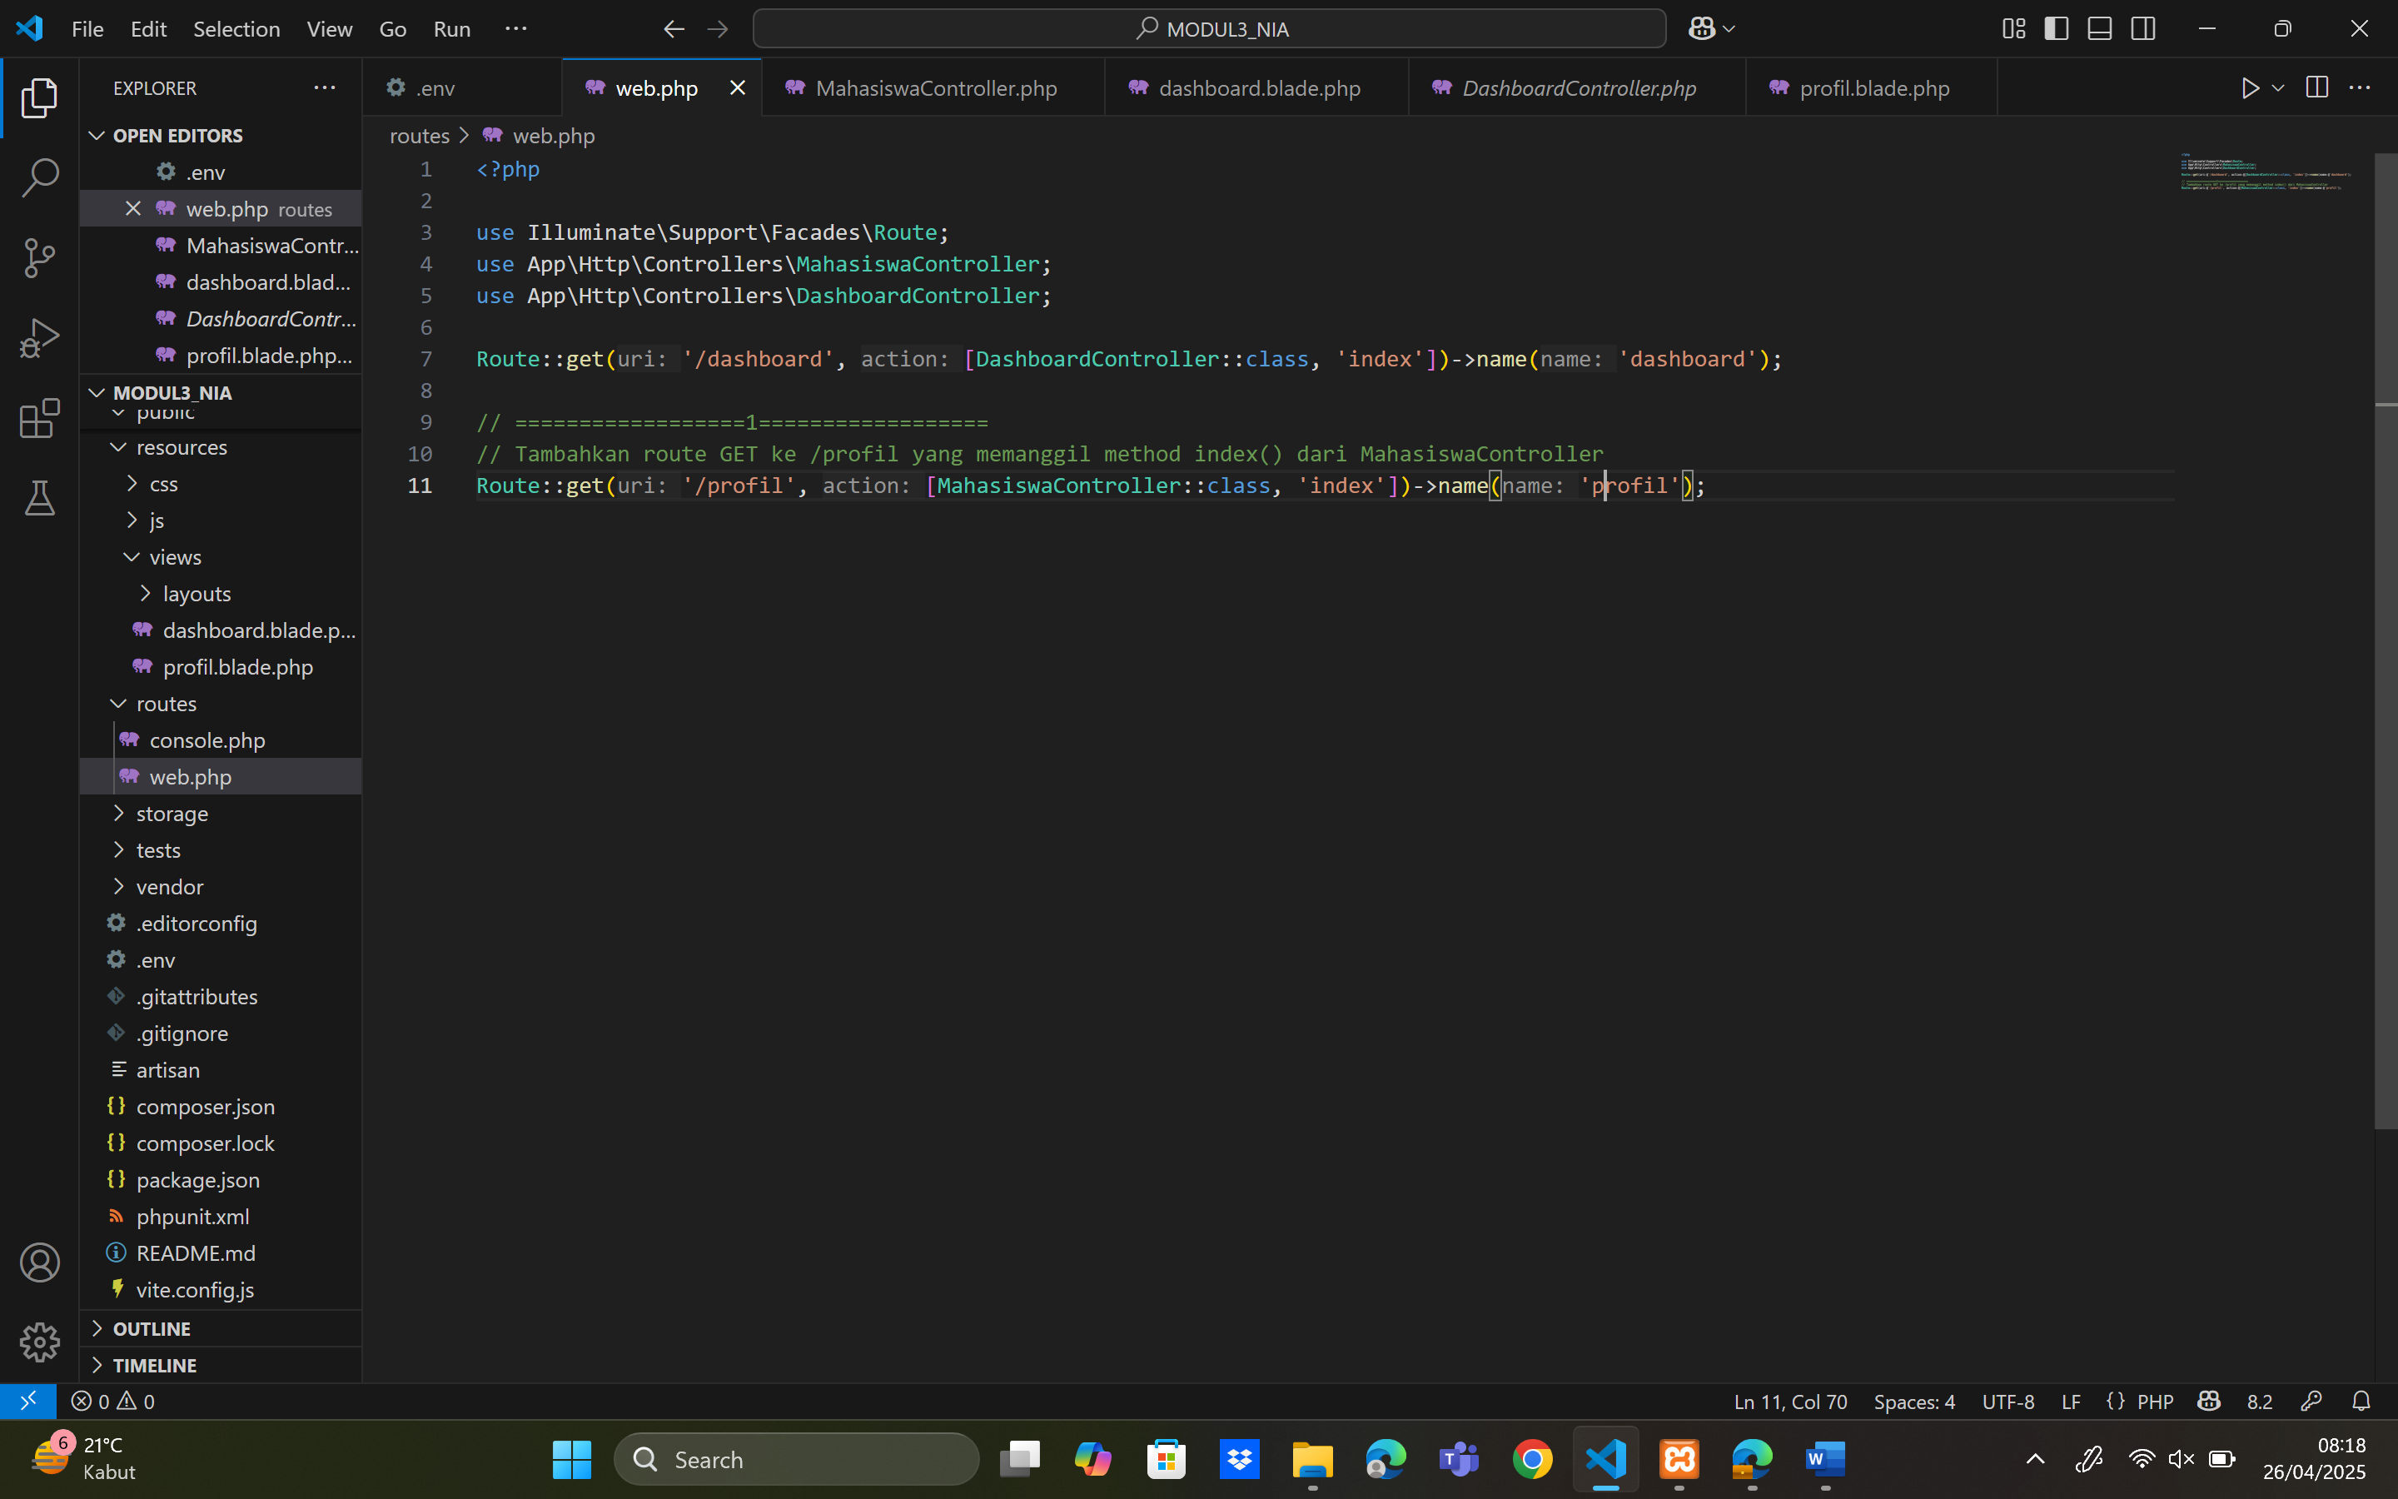

1. app/Http/Controllers/MahasiswaController.php

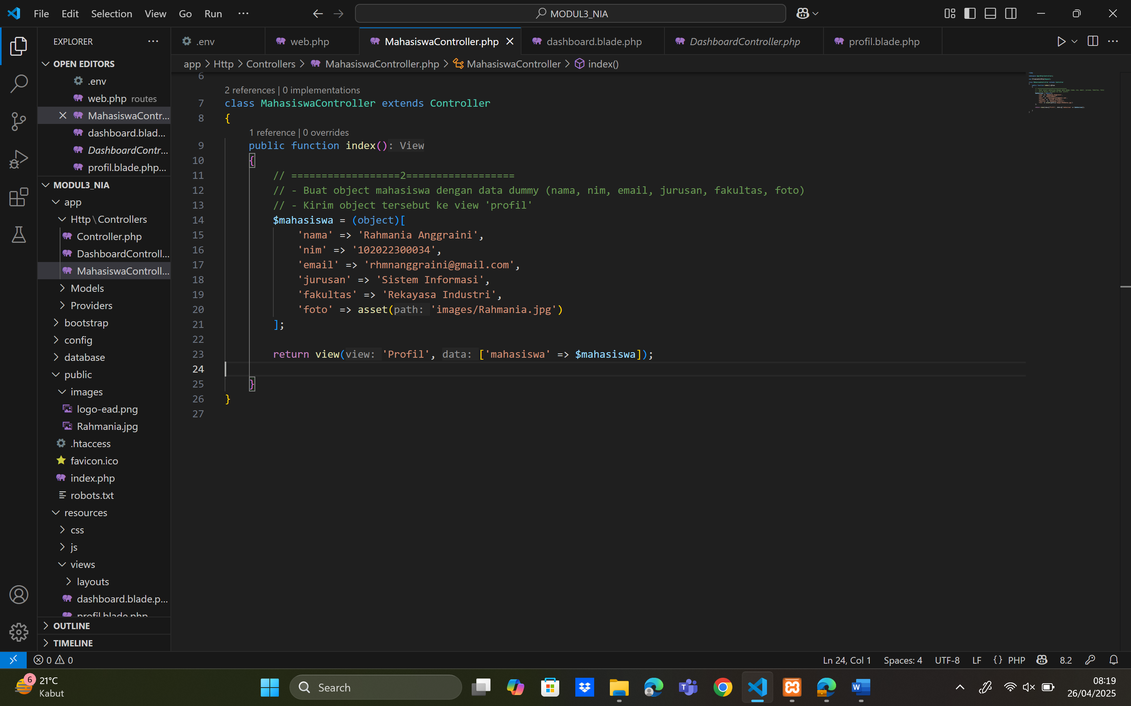

1. resources/views/dashboard.blade.php

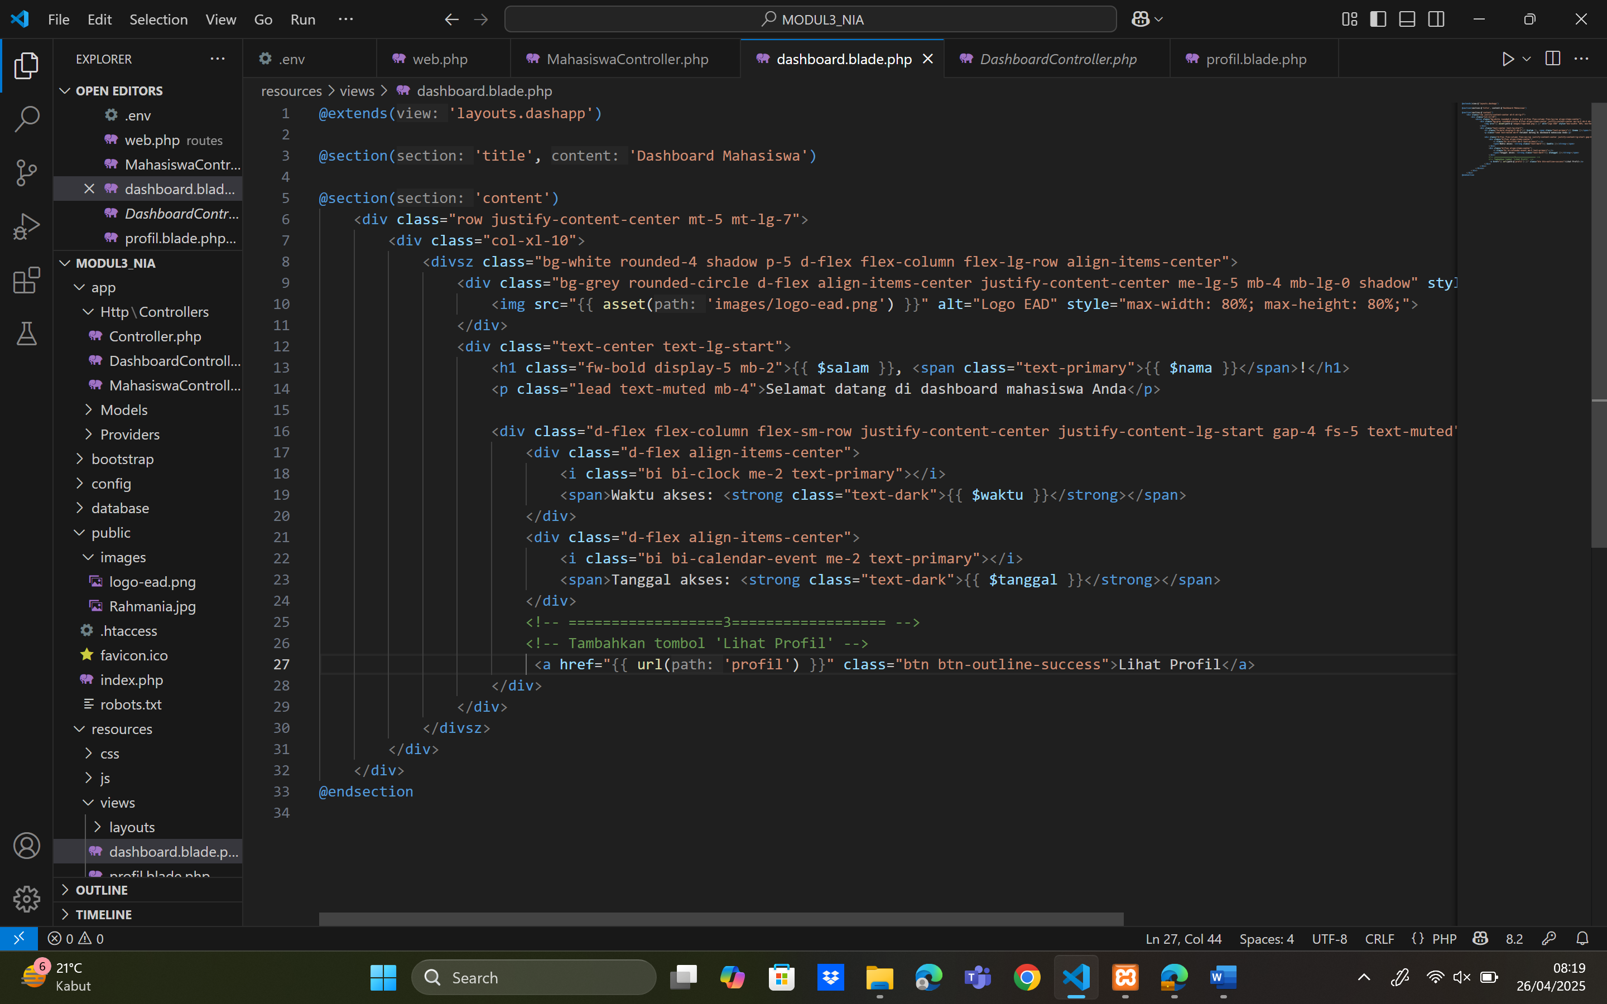

1. resources/views/profil.blade.php

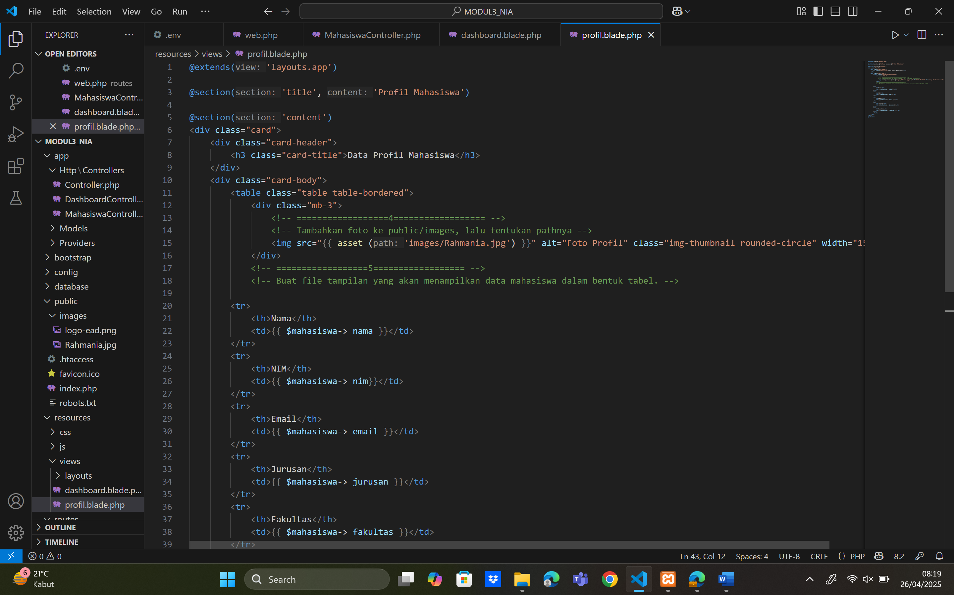

1. HASIL OUTPUT:

